Car Repair Shop

User Manual

Yahor Akusehvich

2017 PJATK

# Main Menu

The main screen of the application. There are all functions of

The database. Top Button helps customers to find there car or get information when its going to be done. Under it red button, gives information about customers etc. Blue button shows prices for job and parts. Yellow one shows emergency phone number, and the grey one gives customer and invoice after work was done.

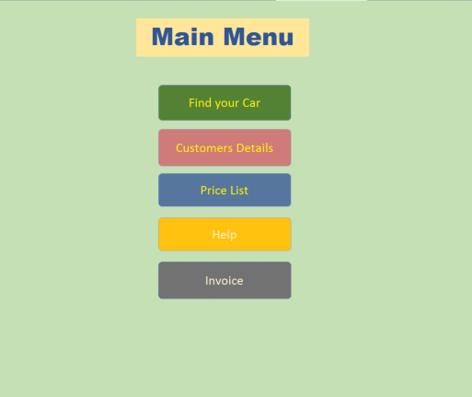

Find Your Car

in this form you can use the search to find your car, u can fill up at list one letter in field, and you will see the results. to go back to the main menu press the **BACK** button.

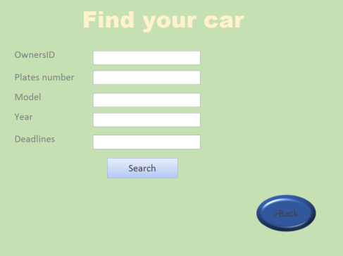

Customers Details

Here you have list of all customers and there details, when you find the information you needed, just click BACK button to go back to main menu.

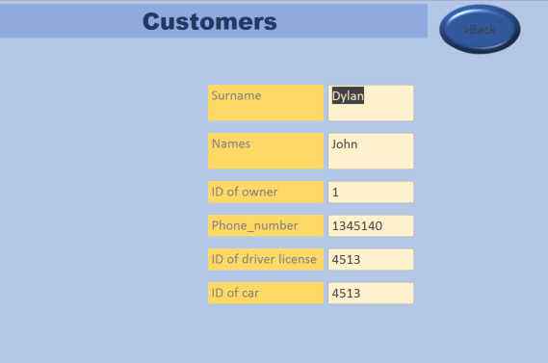

Price List

In price list you can see all prices for work and parts, if you decided to do the work on your car just tell manager the code of work or its name, to go back from this form click **BACK** button.

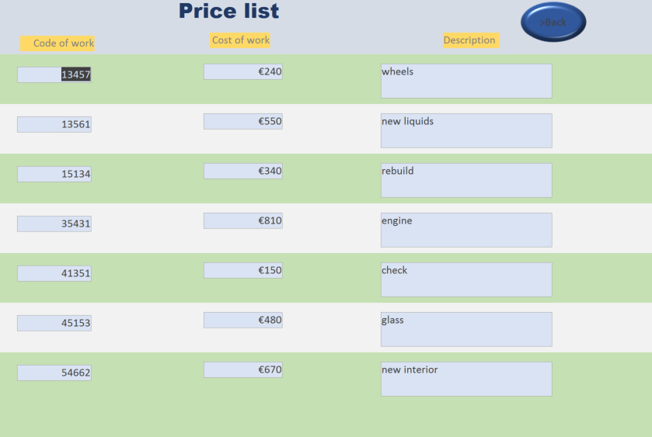

Help

Help button brings up emergency number, if you have problems of any kind, please call us by this number.

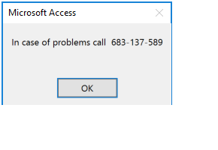

Invoice

After work on your car was done, you will get an invoice, where you can see who did the job on your car, cost of parts and job, and overall price for work.

